Adjustment manual for ERD unit with POTS (rev D)
Table of Contents
1 Tools needed 5
1.1 Dual trace oscilloscope – Digital scope is preferred. 5
1.2 Digital Volt Meter 5
1.3 Philips screw driver 6
2 Remove ERD cover 8
2.1 Turn off the ERD power and remove the power cable 8
2.2 Remove the Ethernet cable and the resolver cable 8
2.3 Remove cable to the indexer 9
2.4 Remove the four screws (green arrows) that hold the cover in place using a Philips screw driver. 10
2.5 Pull cover up with your hands and take it off completely 10
2.6 DANGER – 120 VAC exposed wiring. 11
3 Find the HIGH POINT ON THE RESOLVER 12
3.1 With power off attach channel 1 scope probe to resolver connector Pin 7 12
3.2 Attach channel 2 scope probe to resolver connector Pin 6 12
3.3 Join scope probe grounds together and to the hole at the top of the voltage regulator tab. Please be careful not to bend the tab. 12
3.4 Make sure the ground leads do not touch anything. 12
3.5 Turn on power 14
3.5.1 You will see green LEDs which indicate power is on. 14
3.5.2 You will see red LEDs which indicate there is no resolver cable. 14
3.6 Put the ERD unit and your scope near your resolver cable’s mating connector. 15
3.7 Make sure you are using the actual resolver cable in your setup for these measurements. The cable’s length will make a difference in the voltage readings. 15
3.8 Connect the cable to the resolver. 15
3.9 Observe wave form on the scope. 16
3.9.1 channel 1 sine (yellow) 16
3.9.2 channel 2 cosine (light blue) 16
3.9.3 math channel = channel 1 – channel 2 (channel 1 + channel 2 inverted) (dark blue) 16
3.9.4 set the scope trigger to channel 1. Hopefully there is not too much system noise. 16
3.9.5 Adjust time base on the scope and volts per division on the scope to get the picture below 16
3.10 Using the system controls rotate the resolver until the math channel reaches its peak value. You may rotate it back and forth to make sure you find the peak value. 17
3.11 It is very important that when we adjust the pots we are looking at the peak voltage on the output of the resolver. 17
3.12 Turn off power 18
3.13 Remove the resolver connector and both scope probes and ground. 18
4 Using the DVM Adjust the resistance of the Left and Right Pots 19
4.1 The resolver cable should be disconnected when you make these adjustments. 19
4.2 You must always adjust the pots together so they have about the same resistance. As an example left 8.47k and right 8.47k 19
4.3 Make sure when you are adjusting one POT you are careful not to move the other POT. 19
4.4 Using the DVM raise the resistance of the Left Pot by 500 ohms 19
4.4.1 Put one lead from DVM on Resolver connector Pin 4 and the other lead on the Left header pin1 (see photos) 20
4.4.2 Turn pot CW using your fingers until the DVM reading increases by 500 ohms 20
4.4.3 High resolution photo of where to put the DVM leads for the left pot. It is okay to reverse the red and black leads. 22
4.5 Using DVM raise the resistance of right pot by 500 ohms 23
4.5.1 Put one lead from DVM on Resolver connector Pin 3 and the other lead on the Right header pin1 (see photos) 23
4.5.2 High resolution photo of where to put the DVM leads for the right pot. It is okay to reverse the red and black leads. 24
4.6 Turn the right pot with your fingers CW until its resistance goes up by 500 ohms 25
4.7 Remove DVM leads 26
4.8 Attach channel 1 scope probe to resolver connector Pin 7 26
4.9 Attach channel 2 scope probe to resolver connector Pin 6 26
4.10 Join scope probe grounds together and to the hole at the top of the voltage regulator tab. Please be careful not to bend the tab. 26
4.11 Turn on power 27
4.11.1 You will the two right side green LEDs illuminate and the red leds turn on 27
4.12 Connect the resolver cable. 28
4.12.1 The red leds are on when the resolver chip thinks the resolver signal is bad so at this point they may or may not be on. 28
4.13 Observe wave form on the scope. 29
4.13.1 Channel 1 sine (yellow) 29
4.13.2 Channel 2 cosine (light blue) 29
4.13.3 Math channel = channel 1 – channel 2 (channel 1 + channel 2 inverted) (dark blue) 29
4.14 Using scope measure the voltage on the Math channel 30
4.15 We want the voltage to be in the range 2.15 to 4.0 volts for chip safety. But it works best if the voltage is around 2.90 volts. 30
4.15.1 Try and use the digital read out for Vpp on the screen and avoid reading the voltage directly off the trace. 30
4.16 If we are less than 2.90 volts Go to the BEGINNING OF THIS SECTION and raise the pots another 500 ohms . if we are higher than 2.90 volts then go to the BEGINNING OF THIS SECTION and lower the pots by 100 ohms. The voltage should eventually fall to around 2.8 to 2.9 volts. 30
4.17 Else proceed as follows: 30
4.18 Observe two leds they should no longer be red. 30
4.19 The ERD is now operational 30
5 Connect the Ethernet cable and verify proper operation. 30
5.1 Set the proper IP address as given to you by your IT admin. Every ERD on the network must have a different IP address. 30
5.2 This would be a good time to use a small wooden dowel to press the reset button. I break a Q – tip and use the end. DO NOT USE A PAPER CLIP. 31
5.3 Run your Ethernet test program. 32
5.4 If it passes you are done. 32
5.5 Turn off power 32
5.6 Remove the scope probes 32
5.7 The unit should now look like the photo below 32
6 Replace the cover 33
6.1 Make sure when you put the cover back on the screw holes line up. 33
6.2 If holes do not line up then you must get the tabs on the base to go into the slots. 34
6.3 Replace the four Phillips screws that you removed earlier. 36
6.4 The unit is now ready for operation. 37
7 Warnings 37
7.1 Never connector the resolver to the ERD unit with a shorter cable than the one you used for calibration. The voltage will go up and possibly damage a chip. 37
7.2 It is okay to connect with a longer cable . it might not work because the voltage is too low but it will not cause any damage. 37
8 Troubleshooting 37
8.1 If you have lots of electrical noise make sure the resolver itself is grounded to the same ground as the motor driver. 37
9 Revision History 38
9.1 Rev A – 4/01/2021 manual created 38
9.2 Rev B – 4/05/2020 final edit - released 38

Tools needed

Dual trace oscilloscope – Digital scope is preferred.

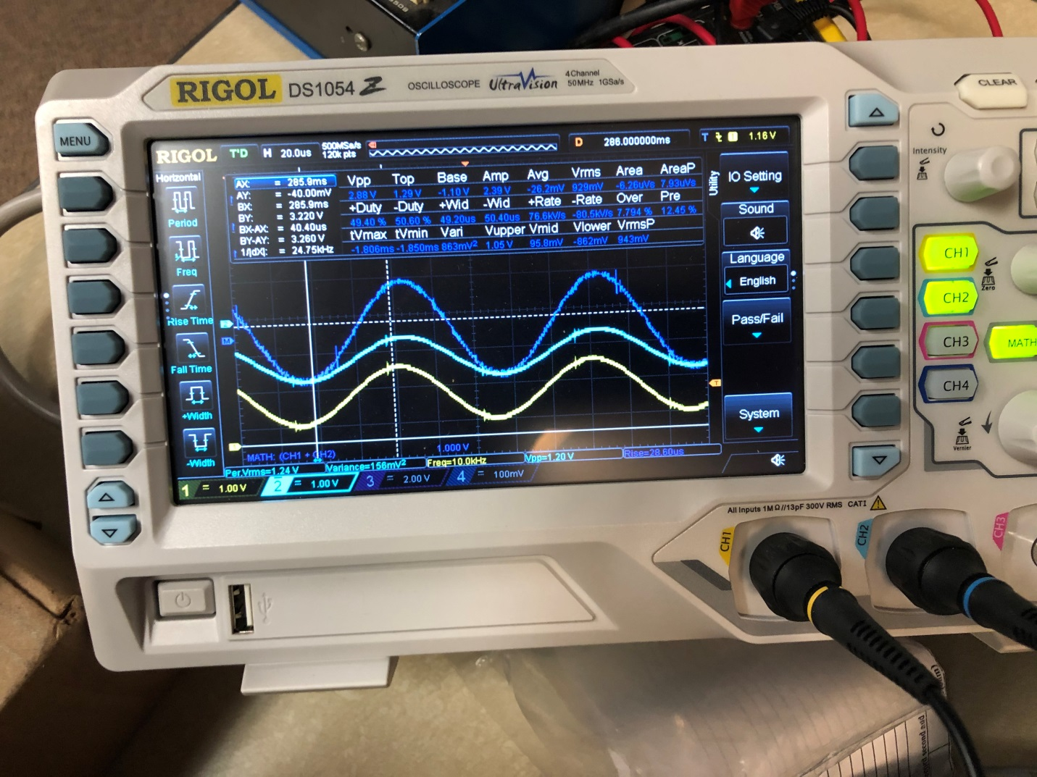

Digital Volt Meter

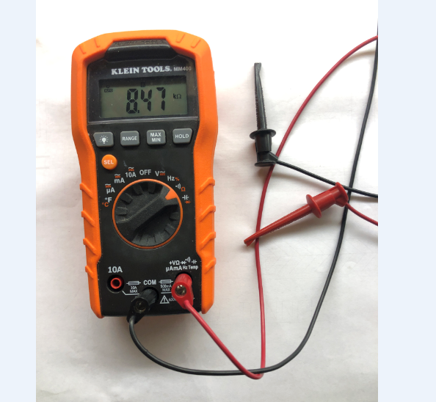

Philips screw driver

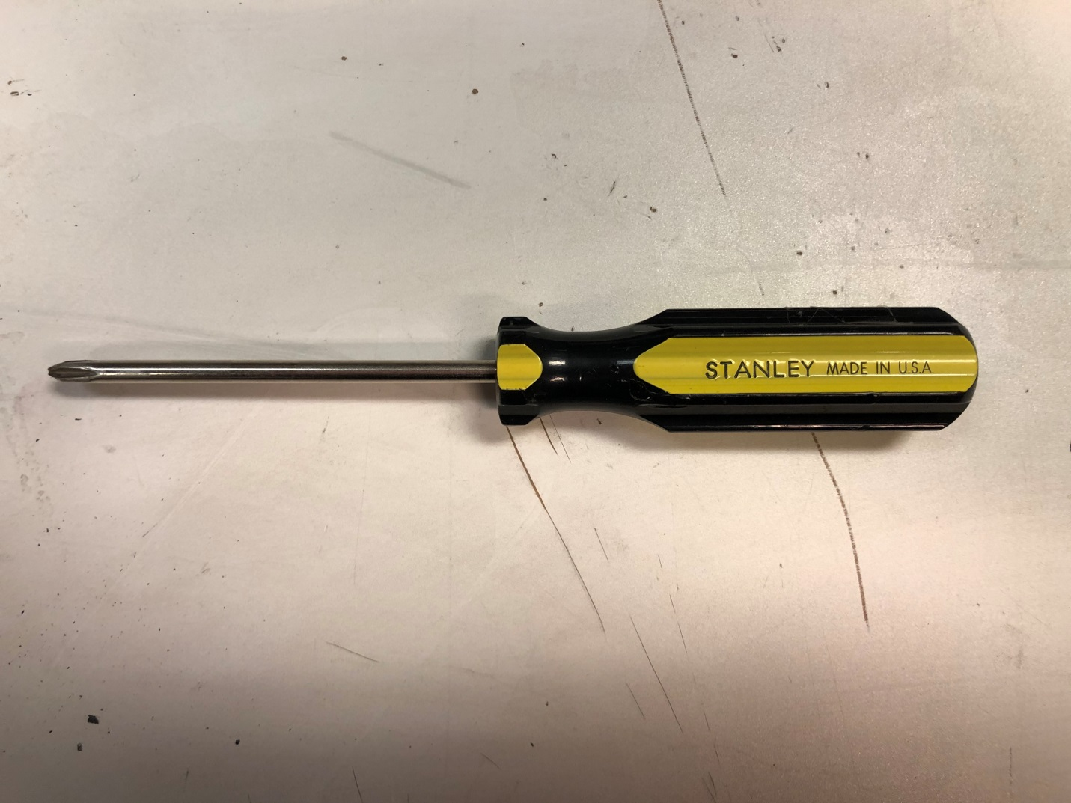

Remove ERD cover

Turn off the ERD power and remove the power cable
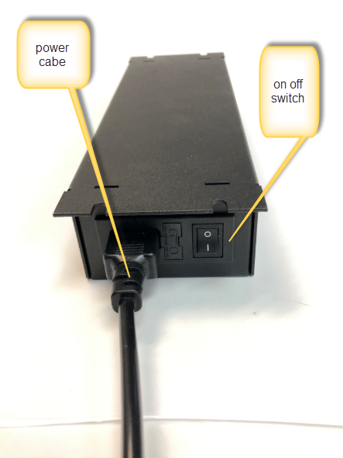

Remove the Ethernet cable and the resolver cable

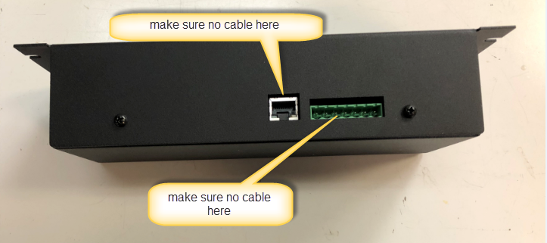

Remove cable to the indexer
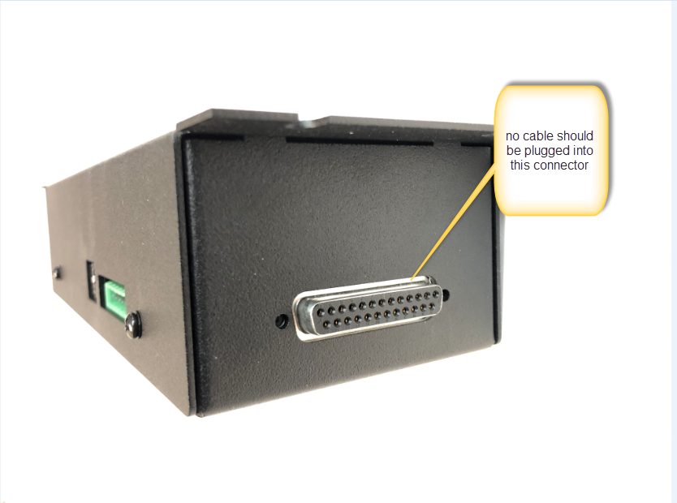

Remove the four screws (green arrows) that hold the cover in place using a Philips screw driver.
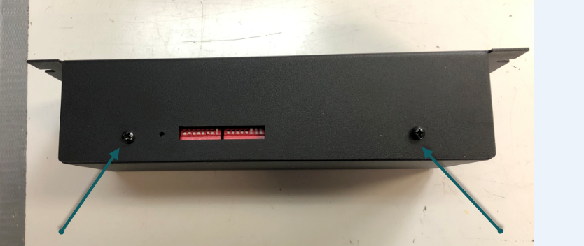
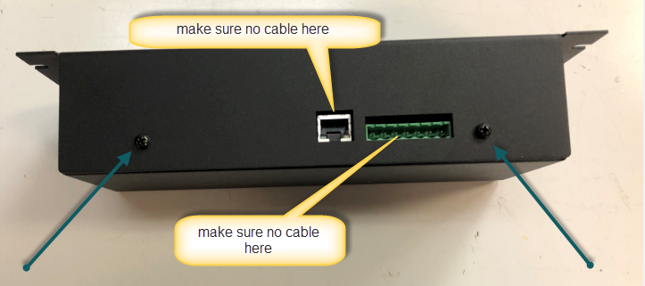

Pull cover up with your hands and take it off completely

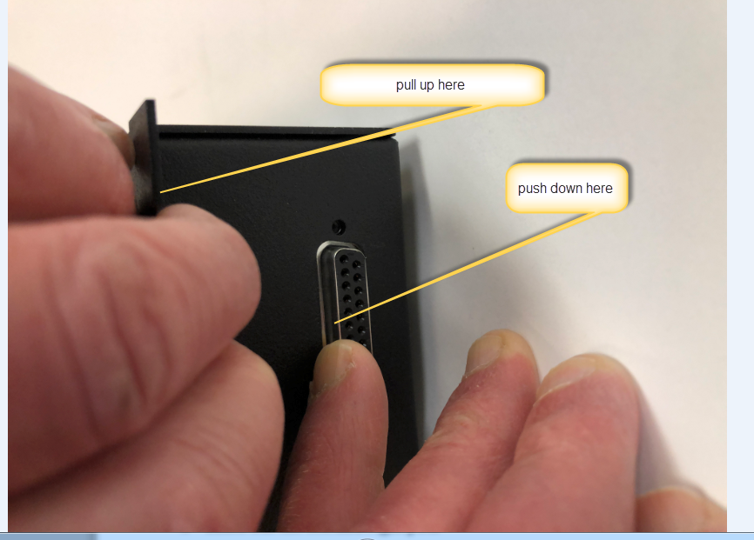

DANGER – 120 VAC exposed wiring.

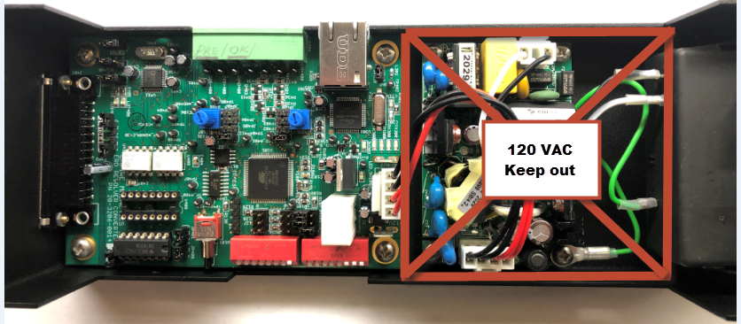

Find the HIGH POINT ON THE RESOLVER

With power off attach channel 1 scope probe to resolver connector Pin 7

Attach channel 2 scope probe to resolver connector Pin 6

Join scope probe grounds together and to the hole at the top of the voltage regulator tab. Please be careful not to bend the tab.
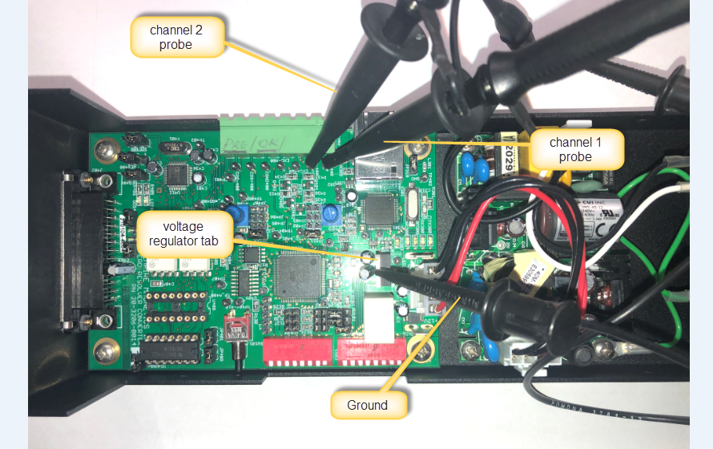

Make sure the ground leads do not touch anything.

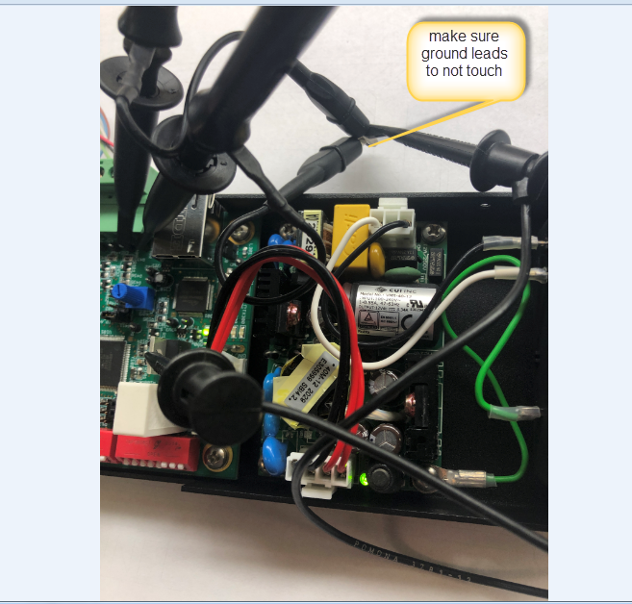

Turn on power

You will see green LEDs which indicate power is on.

You will see red LEDs which indicate there is no resolver cable.

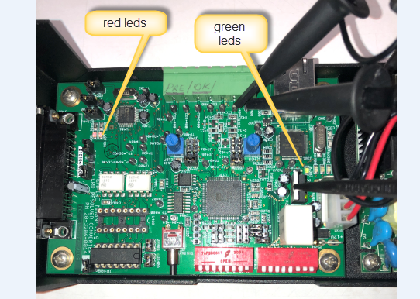

Put the ERD unit and your scope near your resolver cable’s mating connector.

Make sure you are using the actual resolver cable in your setup for these measurements. The cable’s length will make a difference in the voltage readings.

Connect the cable to the resolver.

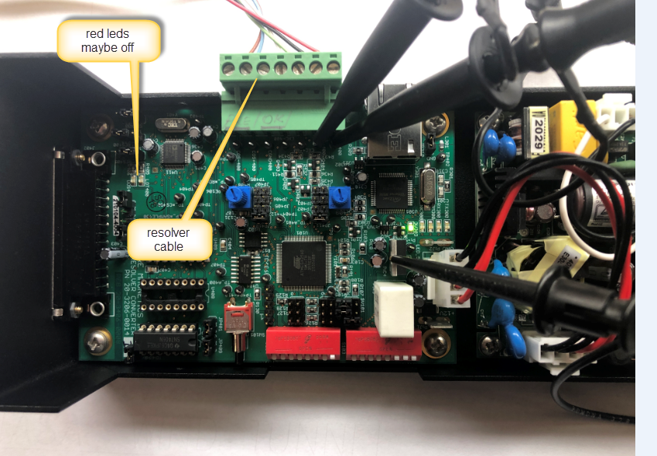

Observe wave form on the scope.

channel 1 sine (yellow)

channel 2 cosine (light blue)

math channel = channel 1 – channel 2 (channel 1 + channel 2 inverted) (dark blue)

set the scope trigger to channel 1. Hopefully there is not too much system noise.

Adjust time base on the scope and volts per division on the scope to get the picture below
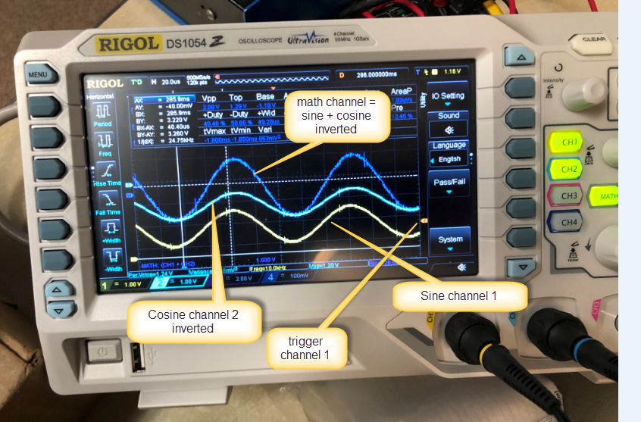

Using the system controls rotate the resolver until the math channel reaches its peak value. You may rotate it back and forth to make sure you find the peak value.

It is very important that when we adjust the pots we are looking at the peak voltage on the output of the resolver.
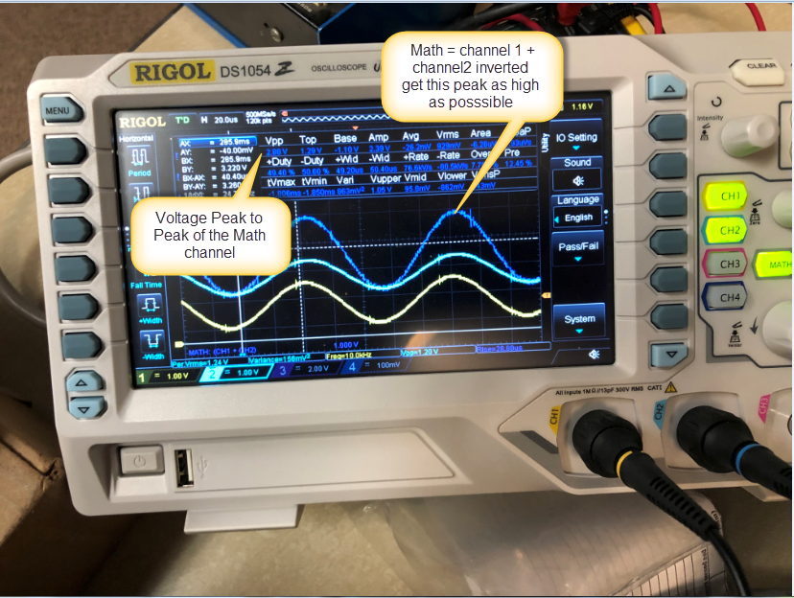

Turn off power
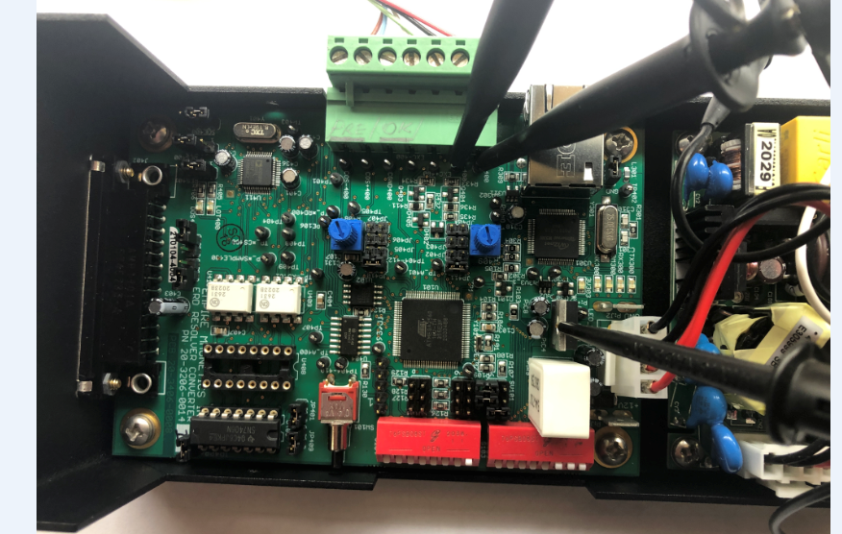

Remove the resolver connector and both scope probes and ground.
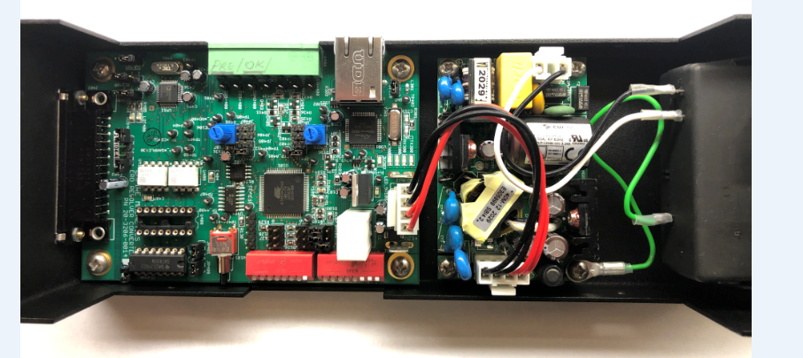

Using the DVM Adjust the resistance of the Left and Right Pots

The resolver cable should be disconnected when you make these adjustments.

You must always adjust the pots together so they have about the same resistance. As an example left 8.47k and right 8.47k

Make sure when you are adjusting one POT you are careful not to move the other POT.

Using the DVM raise the resistance of the Left Pot by 500 ohms

Put one lead from DVM on Resolver connector Pin 4 and the other lead on the Left header pin1 (see photos)
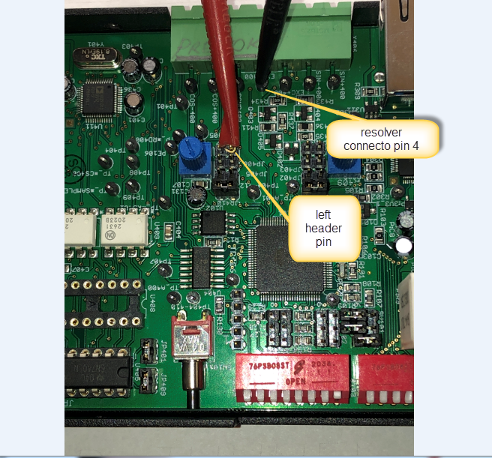

Turn pot CW using your fingers until the DVM reading increases by 500 ohms

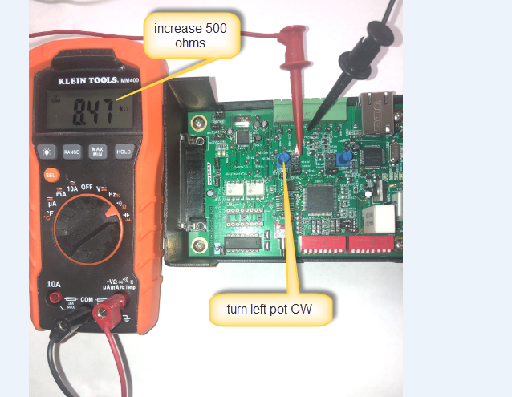

High resolution photo of where to put the DVM leads for the left pot. It is okay to reverse the red and black leads.
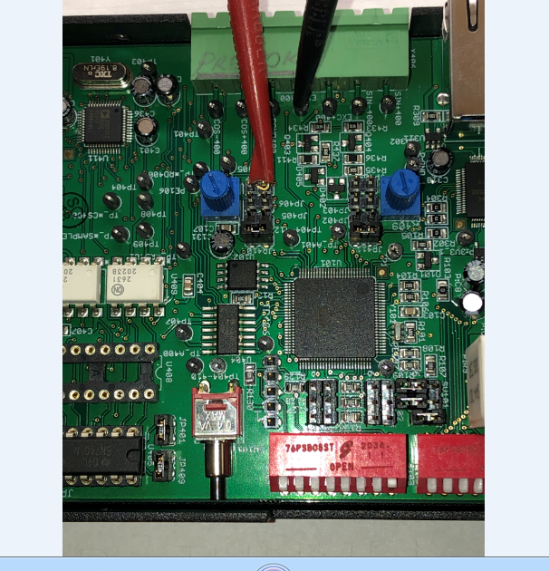

Using DVM raise the resistance of right pot by 500 ohms

Put one lead from DVM on Resolver connector Pin 3 and the other lead on the Right header pin1 (see photos)
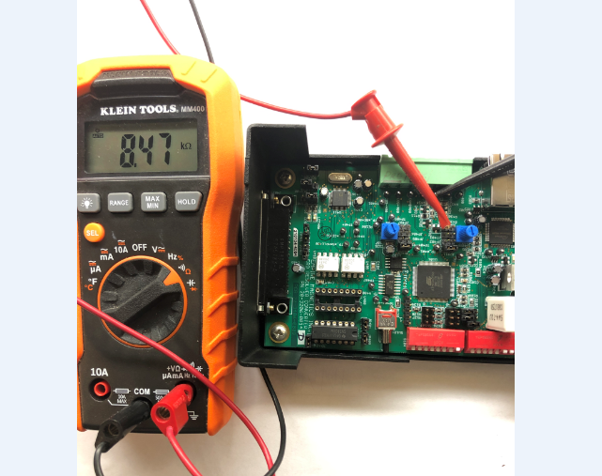

High resolution photo of where to put the DVM leads for the right pot. It is okay to reverse the red and black leads.
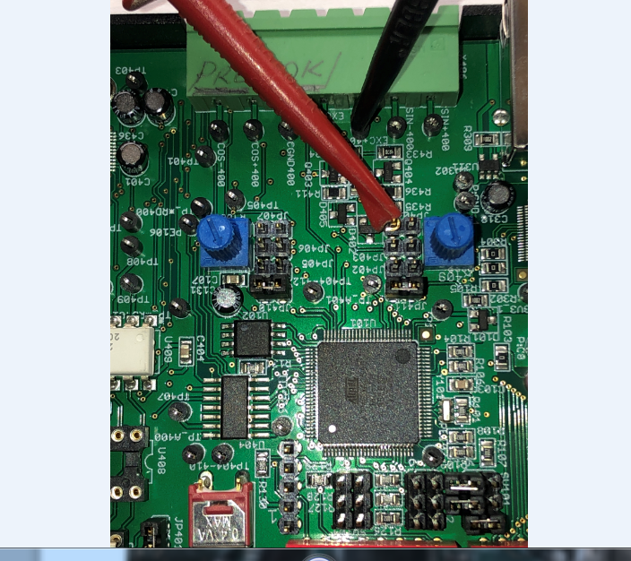

Turn the right pot with your fingers CW until its resistance goes up by 500 ohms
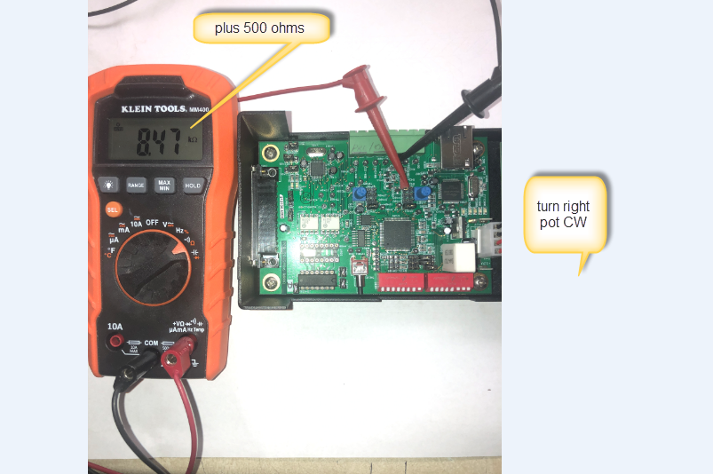

Remove DVM leads

Attach channel 1 scope probe to resolver connector Pin 7

Attach channel 2 scope probe to resolver connector Pin 6

Join scope probe grounds together and to the hole at the top of the voltage regulator tab. Please be careful not to bend the tab.

Turn on power

You will the two right side green LEDs illuminate and the red leds turn on

Connect the resolver cable.

The red leds are on when the resolver chip thinks the resolver signal is bad so at this point they may or may not be on.

Observe wave form on the scope.

Channel 1 sine (yellow)

Channel 2 cosine (light blue)

Math channel = channel 1 – channel 2 (channel 1 + channel 2 inverted) (dark blue)
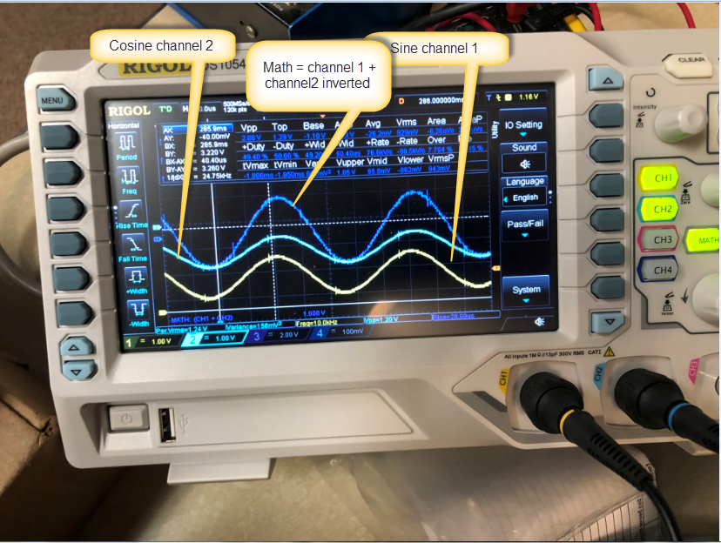

Using scope measure the voltage on the Math channel

We want the voltage to be in the range 2.15 to 4.0 volts for chip safety. But it works best if the voltage is around 2.90 volts.

Try and use the digital read out for Vpp on the screen and avoid reading the voltage directly off the trace.

If we are less than 2.90 volts Go to the BEGINNING OF THIS SECTION and raise the pots another 500 ohms . if we are higher than 2.90 volts then go to the BEGINNING OF THIS SECTION and lower the pots by 100 ohms. The voltage should eventually fall to around 2.8 to 2.9 volts.

Else proceed as follows:

Observe two leds they should no longer be red.

The ERD is now operational

Connect the Ethernet cable and verify proper operation.

Set the proper IP address as given to you by your IT admin. Every ERD on the network must have a different IP address.
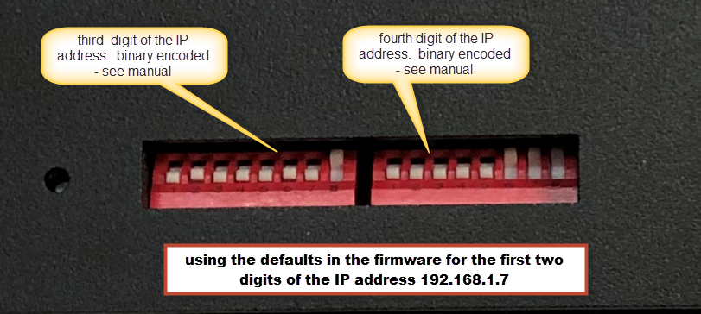

This would be a good time to use a small wooden dowel to press the reset button. I break a Q – tip and use the end. DO NOT USE A PAPER CLIP.
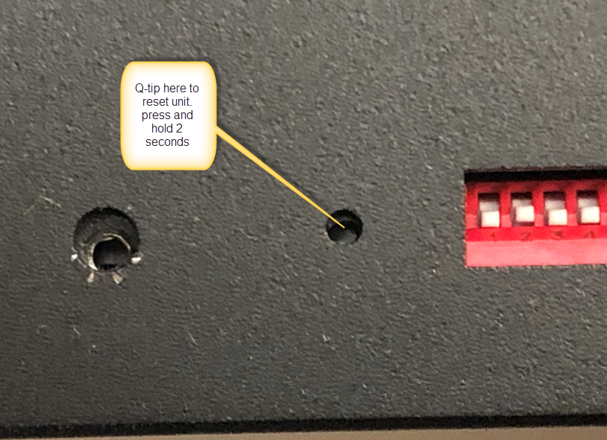

Run your Ethernet test program.

If it passes you are done.

Turn off power

Remove the scope probes

The unit should now look like the photo below
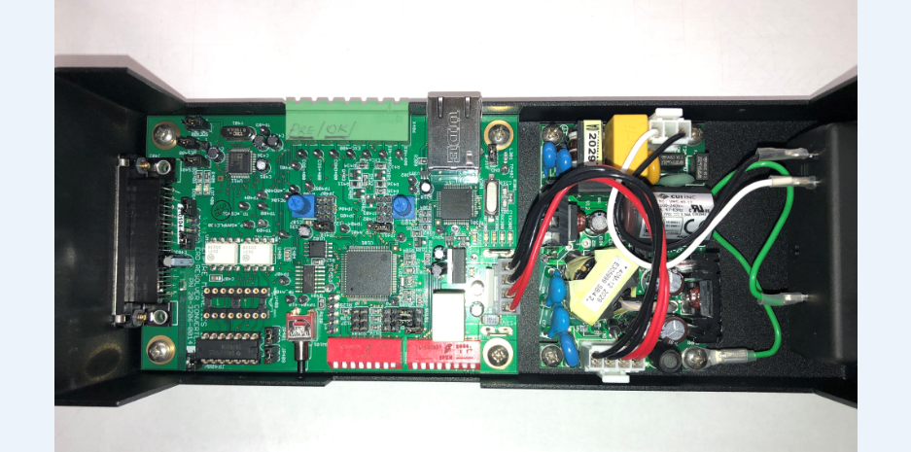

Replace the cover

Make sure when you put the cover back on the screw holes line up.
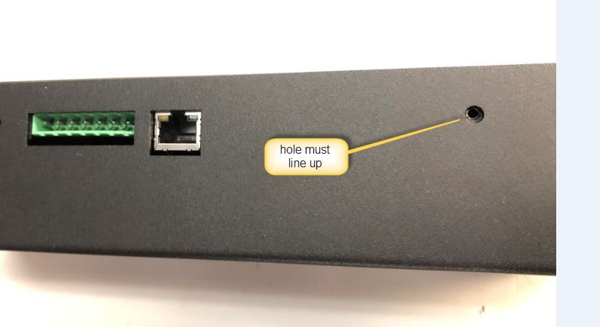

If holes do not line up then you must get the tabs on the base to go into the slots.
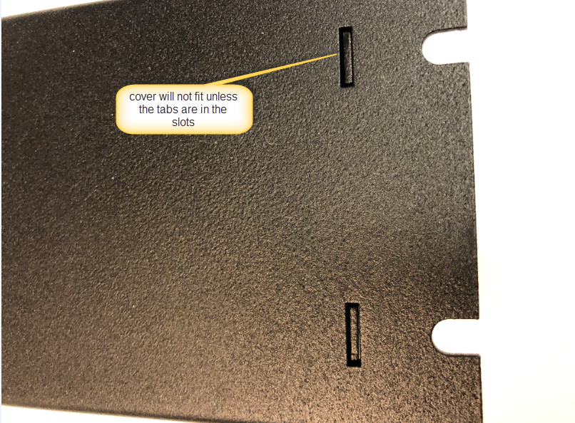
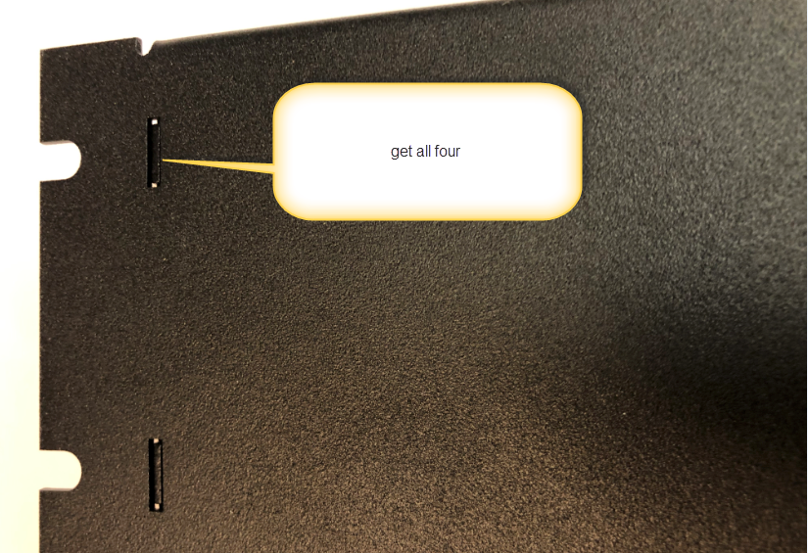

Replace the four Phillips screws that you removed earlier.
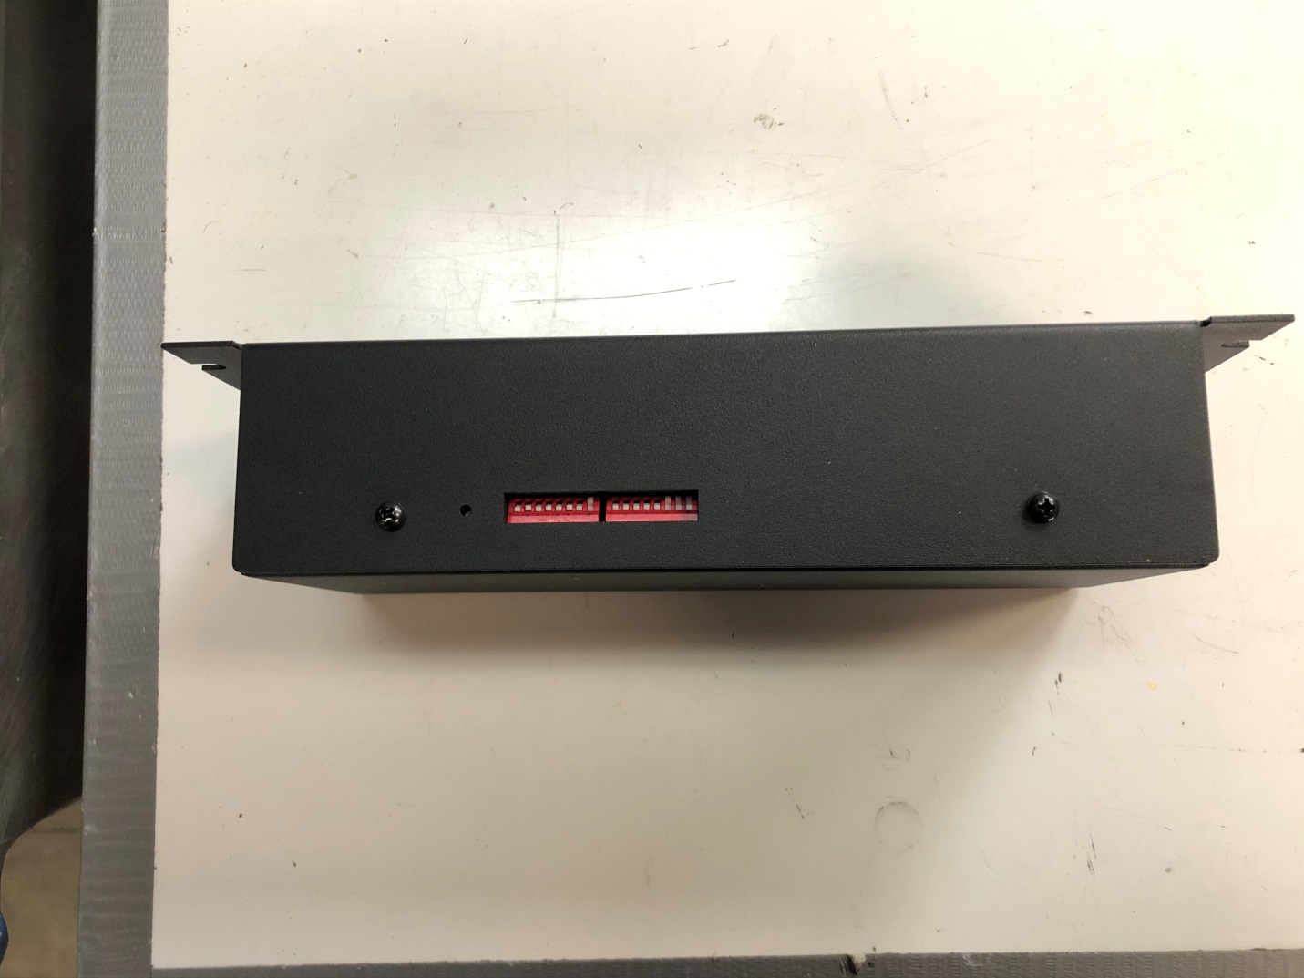
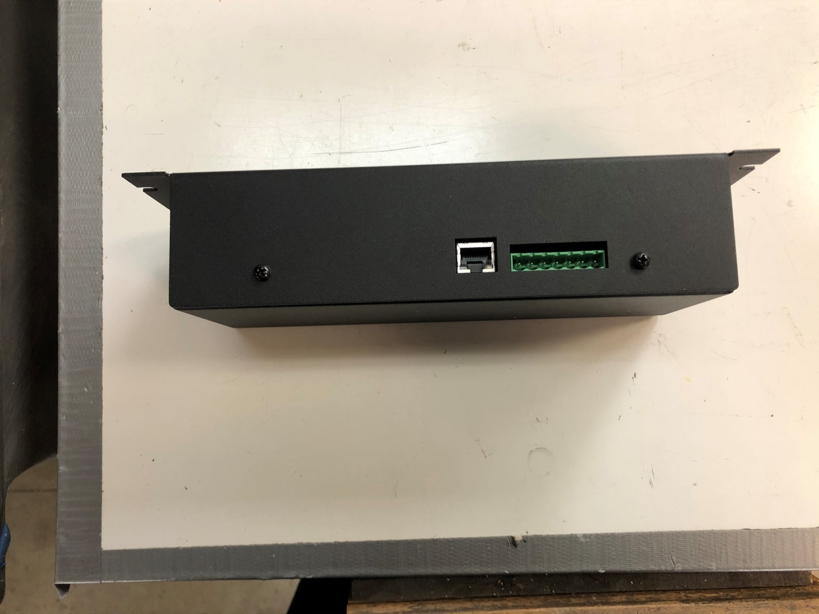

The unit is now ready for operation.

Warnings

Never connector the resolver to the ERD unit with a longer cable than the one you used for calibration. The voltage will go up and possibly damage a chip.

It is okay to connect with a shorter cable. It might not work because the voltage is too low but it will not cause any damage.

Troubleshooting

If you have lots of electrical noise make sure the resolver itself is grounded to the same ground as the motor driver.

Revision History

Rev A – 4/01/2021 manual created

Rev B – 4/05/2020 final edit - released

